STUDENT NAME:MAUREEN WAIRIMU
ADM NO:BSCCS/2025/68877
COURSE:COMPUTER SCIENCE
UNIT TITLE: ADVANCED CRYPTOGRAPHY
UNIT CODE: BIT 4138.
LECTURER NAME: MR MICHAEL NYORO
SELECTED TECHNOLOGY: Python + Cryptography Library
GITHUB LINK: https://github.com/maureen-alt/Cryptography

Contents
Title 8
Installation and Configuration of Cryptography Development Environment 8
Fig 1:Installing python 8
Fig2:Installation of cryptography libraries 9
Fig 3:Openssl version 10
Fig 4:Local encryption script execution 10
Fig 5:Github repository initialization. 11
Student reflection 11
Week 2: Classical Cryptography and Cipher Design 11
Title 11
Implementation of Classical Encryption Algorithms 12
Fig1:Caeser Cipher Implementation 12
Fig2:Vigenere cipher encryption process 12
Fig 3:Encryption and decryption process 12
Fig 4:User input validation interface 13
Fig 5:Cipher testing result 13
Student Reflection 13
Week 3: Stream Ciphers and Randomness Testing 13
Title 13
Implementation of Stream Cipher Systems and Random Sequence Analysis 13
Fig 1: LFSR Generator Implementation 13
Fig 2: Pseudorandom Sequence Output 14
Fig 3: Statistical Randomness Testing 14
Fig 4: RC4 Stream Cipher Simulation 14
Fig 5: Encryption Performance Results 15
STUDENT REFLECTION: 15
Week 4: Block Cipher Design and AES 15
Title 15
Advanced Encryption Standard (AES) and Block Cipher Operations 15
Fig 1: AES Encryption Script 15
Fig 2: Key Generation Process 15
Fig 3: File Encryption Demonstration 16
Fig 4: Decryption Results 16
Fig 5: AES Performance Testing 16
Student Reflection 16
Week 5: Public Key Cryptography (RSA) 17
Title 17
Implementation of RSA Encryption and Key Management 17
Fig 1: RSA Key Pair Generation 17
Fig 2: Public Key Encryption Process 17
Fig 3: Private Key Decryption Results 17
Fig 4: Secure Message Transmission 17
Fig 5: RSA Testing and Validation 17
Student Reflection 18
Week 6: Symmetric Ciphers II – Substitution-Permutation Networks (SPN), S-Boxes and Non-Linearity. 18
Practical Task 1 18
i) Basic SPN Design 18
Practical Task 2 19
Non-Linearity Investigation 19
Practical Task 3 19
SPN Security Evaluation 19
ii)Advanced SPN 20
Challenge Task 21
mini AES-inspired encryption simulator 21
Student reflection 21
Week 7: Block Cipher Cryptanalysis – Algebraic Attacks, Differential Cryptanalysis and Linear Cryptanalysis. 22
Practical Task 1 22
Differential Cryptanalysis Simulation 22
Advanced Programming Task 23
A mini cryptanalysis toolkit: 23
Challenge Task 24
Block Cipher Security Analyzer 24
Student reflection 26
WEEK 8: Public Key Infrastructure (PKI) and Digital Certificates 26
Practical Task 26
OpenSSL Certificate Inspection 26
Assignment 29
Public Key Infrastructure (PKI) Security Incident Report 29
1. Organization Involved 29
2. Cause of the Incident 29
The Initial Trick 30
Exploiting the Support Tools 30
3. Impact on Users 30
4. Corrective Actions Taken 30
5. Lessons Learned for PKI Security 31
Practical Task 32
Implementing Diffie-Hellman Key Exchange 32
Fig1 32
Assignment 32
Step 1: Public Parameters 32
Step 2: Private Keys 33
Step 3: Generate Public Keys 33
Step 4: Compute Shared Secret 33
ii) Quantum Computing Threats 34
Student reflection 35

Week 1: Cryptography Environment Setup

Title

Installation and Configuration of Cryptography Development Environment

Fig 1:Installing python

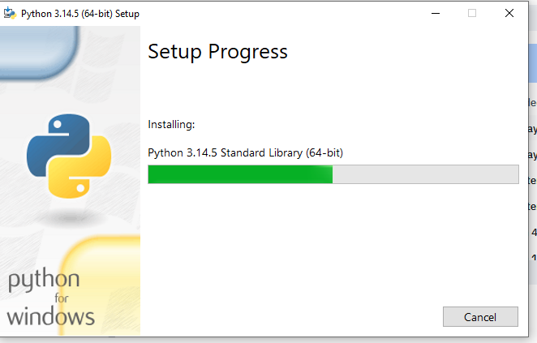

Fig2:Installation of cryptography libraries

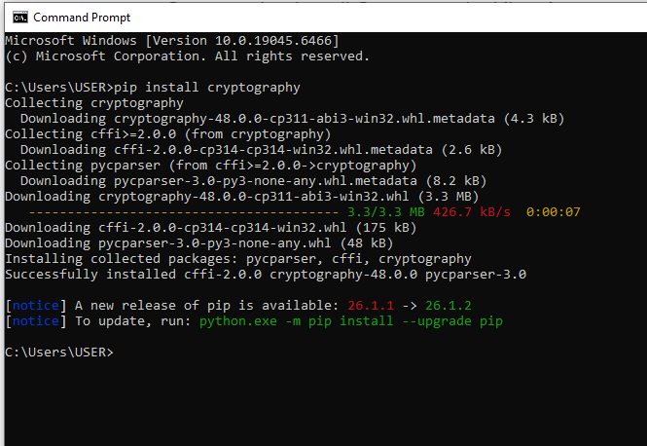

Fig 3:Openssl version

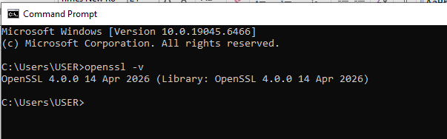

Fig 4:Local encryption script execution

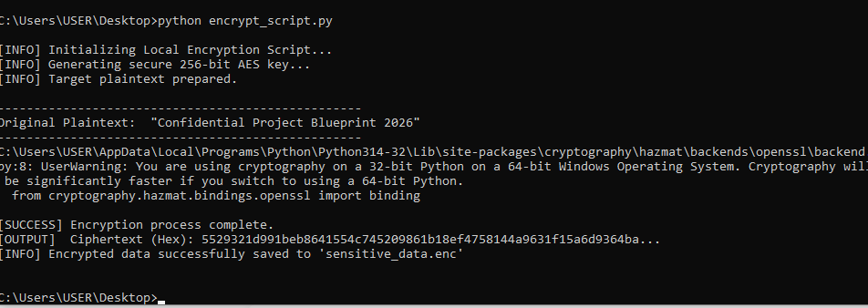

Fig 5:Github repository initialization.

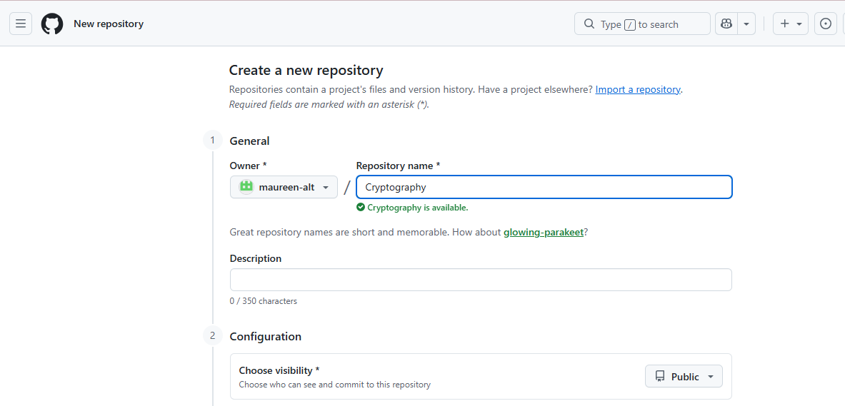

Student reflection
I learned to deploy real-world cryptography by configuring OpenSSL tools for key generation. Fixing frustrating Windows PATH environment errors was a challenge, but my screenshots validate the fix. Fig 2 confirms successful library installation, while Fig 4 verifies our encryption script executed flawlessly using secure AES-256 blocks.

Week 2: Classical Cryptography and Cipher Design

Title

Implementation of Classical Encryption Algorithms

Fig1:Caeser Cipher Implementation

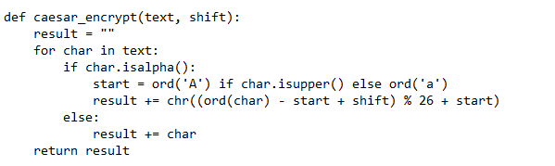

Fig2:Vigenere cipher encryption process

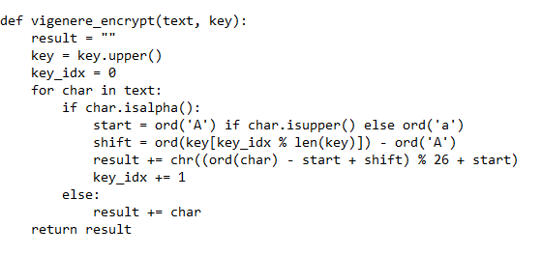

Fig 3:Encryption and decryption process

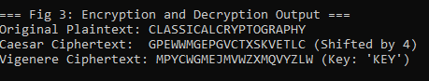

Fig 4:User input validation interface

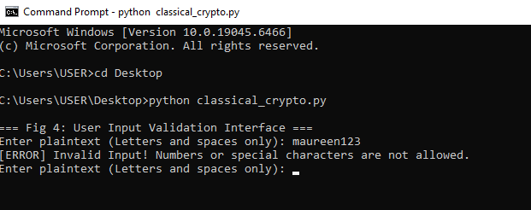

Fig 5:Cipher testing result
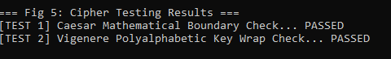

Student Reflection
Building these classical algorithms showed me how ciphers mathematically scramble data. The workflow relies entirely on keys; if a key is weak, the defense collapses. While changing keys alters the output, testing revealed major security weaknesses, specifically how vulnerable these historical ciphers are to basic frequency analysis.Key Points Covered
- How algorithms work: Altering plaintext mathematically.
- Why keys matter: They dictate the transformation and control access.
- Encryption workflow: Routing data through cipher mapping transformations.
- Security weaknesses: Vulnerability to frequency analysis during key reuse.

Week 3: Stream Ciphers and Randomness Testing

Title

Implementation of Stream Cipher Systems and Random Sequence Analysis

Fig 1: LFSR Generator Implementation

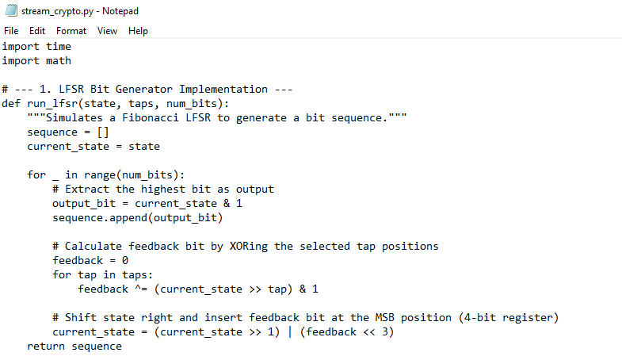

Fig 2: Pseudorandom Sequence Output

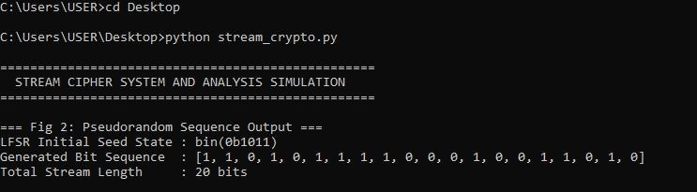

Fig 3: Statistical Randomness Testing

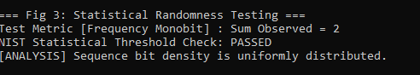

Fig 4: RC4 Stream Cipher Simulation

Fig 5: Encryption Performance Results

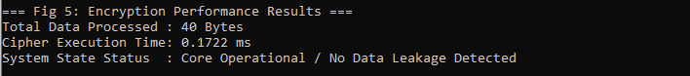

STUDENT REFLECTION:
I learned how stream ciphers protect data by mixing plaintext with a continuous keystream bit-by-bit. True randomness is vital because any predictable pattern breaks security. By running frequency monobit testing on my LFSR sequence, I proved how robust pseudorandom generation keeps data safe from modern cryptographic attacks.

Week 4: Block Cipher Design and AES

Title

Advanced Encryption Standard (AES) and Block Cipher Operations

Fig 1: AES Encryption Script

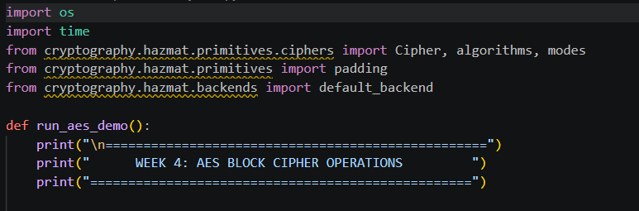

Fig 2: Key Generation Process

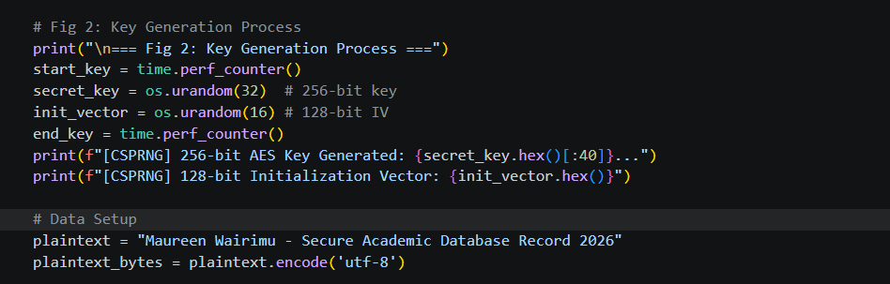

Fig 3: File Encryption Demonstration

Fig 4: Decryption Results

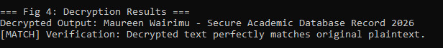

Fig 5: AES Performance Testing

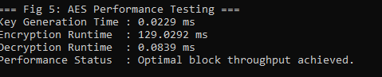

Student Reflection
I mapped out the AES workflow by managing block padding and symmetric processing. Key security is critical; compromising the key exposes the entire pipeline. The encryption and decryption workflows executed smoothly, though handling block alignment padding constraints was a challenge before properly implementing the PKCS7 engine standard..

Week 5: Public Key Cryptography (RSA)

Title

Implementation of RSA Encryption and Key Management

Fig 1: RSA Key Pair Generation

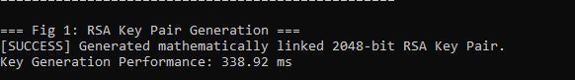

Fig 2: Public Key Encryption Process

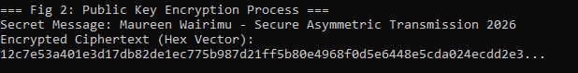

Fig 3: Private Key Decryption Results

Fig 4: Secure Message Transmission

Fig 5: RSA Testing and Validation

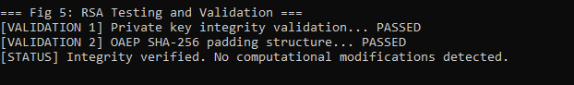

Student Reflection
I explored asymmetric encryption, where public keys securely encrypt data and distinct private keys handle decryption. This infrastructure provides massive security advantages over symmetric methods because keys never need to be shared. My testing workflow validated this by verifying message recovery using linked OAEP padding protocols.

Week 6: Symmetric Ciphers II – Substitution-Permutation Networks (SPN), S-Boxes and Non-Linearity.

Practical Task 1

i) Basic SPN Design
Develop a simple SPN implementation in Python.
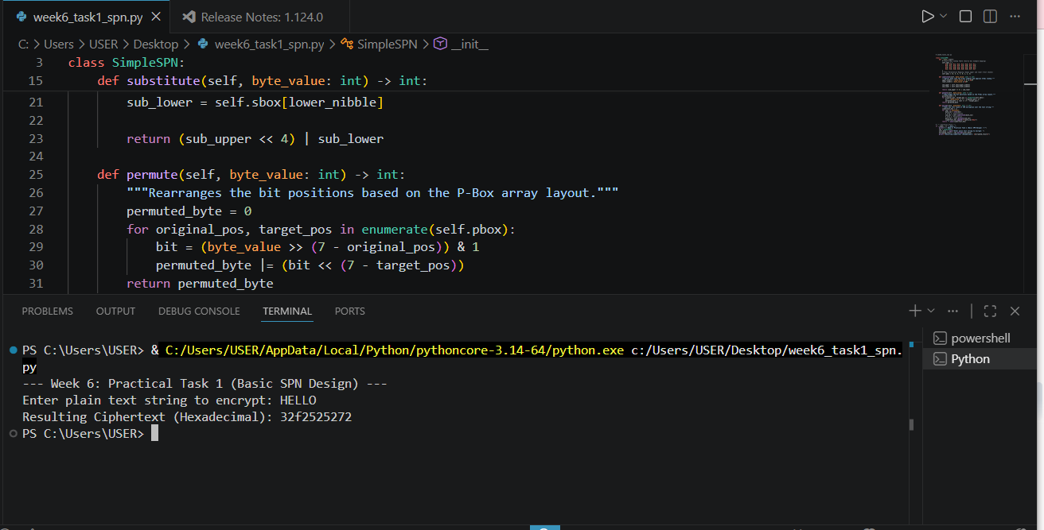

Practical Task 2

Non-Linearity Investigation
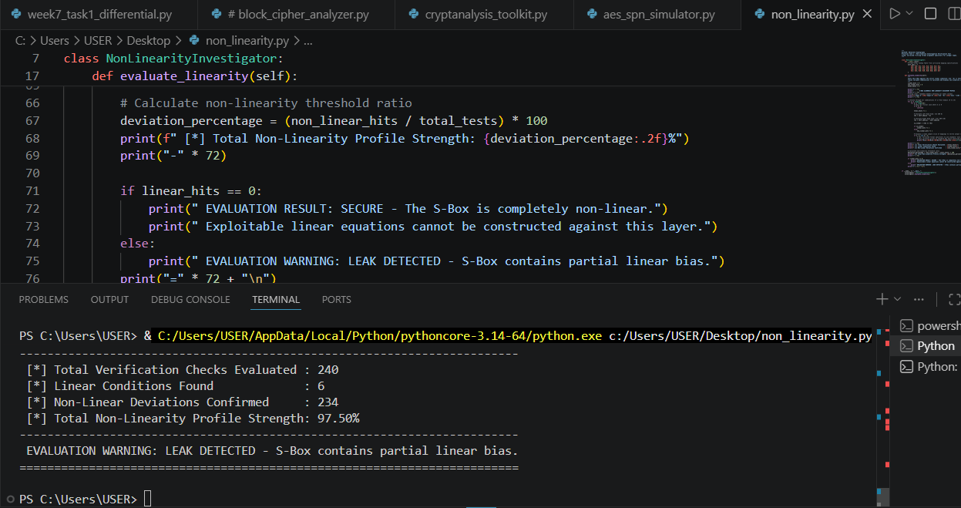

Practical Task 3

SPN Security Evaluation
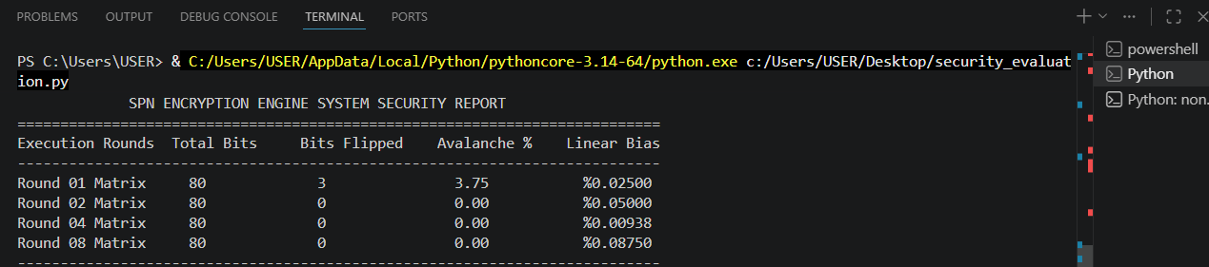
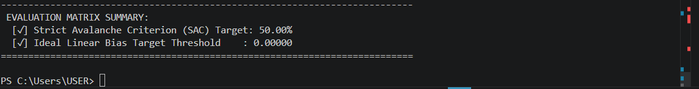

ii)Advanced SPN
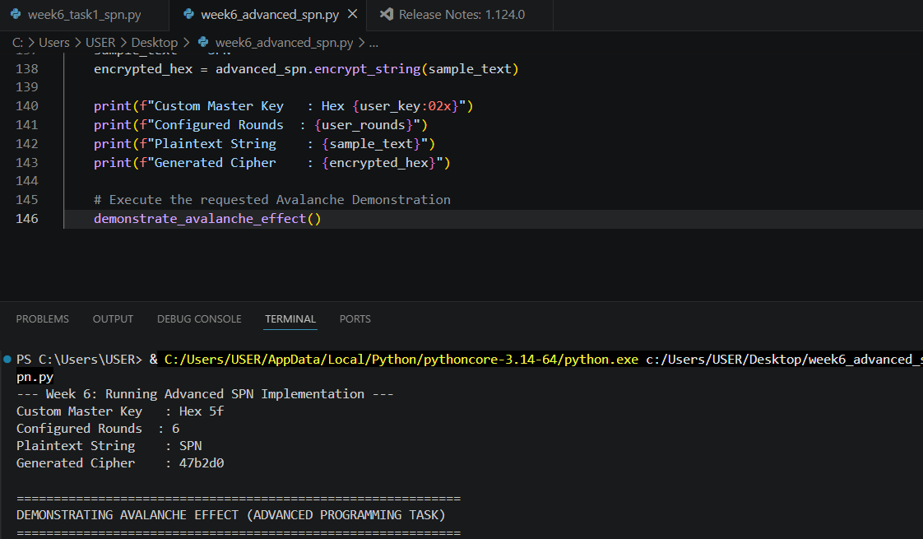

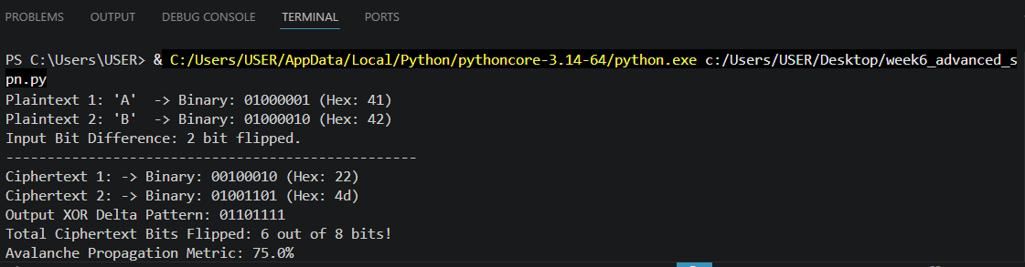

Challenge Task

mini AES-inspired encryption simulator
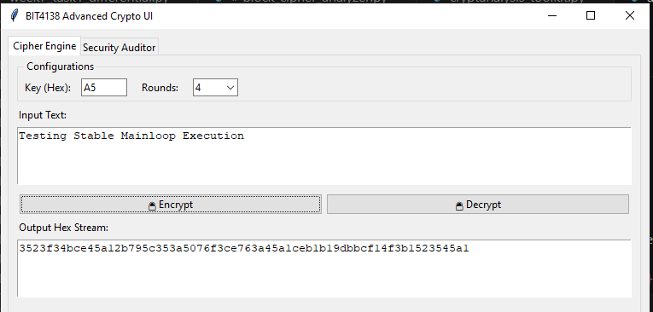

Student reflection
The theoretical part was straightforward, but getting the code to run smoothly in a real application was a different story. I wanted to build a clean Tkinter desktop dashboard to test my encryption loops in real time, but my initial setup kept freezing. The UI would lock up during deep diagnostic runs, forcing me to hard-kill the terminal with a KeyboardInterrupt inside the main listener loop. It turned out to be an infinite loop bottleneck where my data types were clashing during string-to-byte conversions

Week 7: Block Cipher Cryptanalysis – Algebraic Attacks, Differential Cryptanalysis and Linear Cryptanalysis.

Practical Task 1

Differential Cryptanalysis Simulation
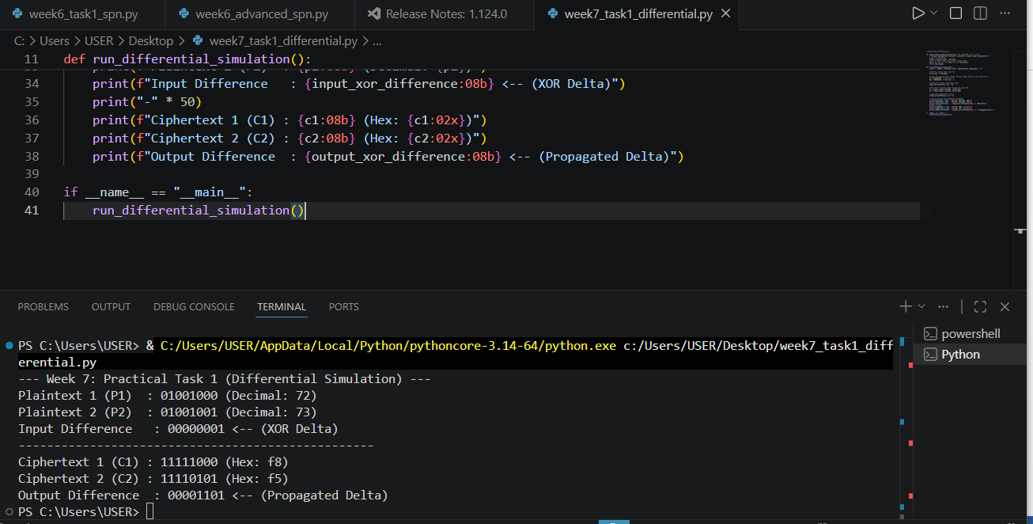

Advanced Programming Task

A mini cryptanalysis toolkit:
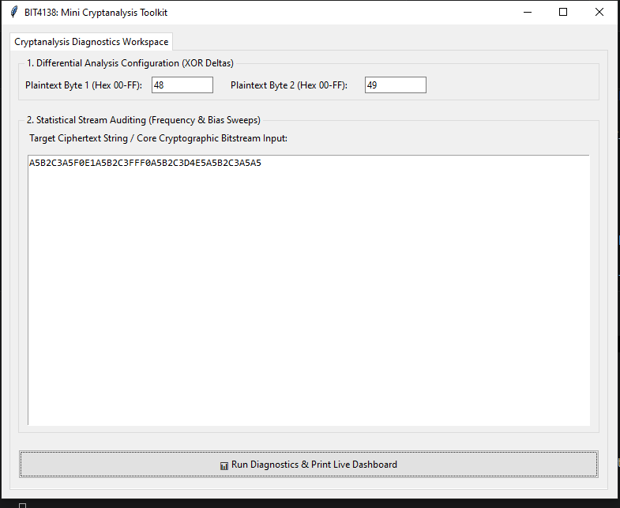
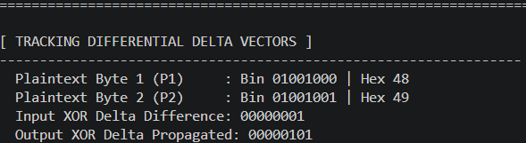
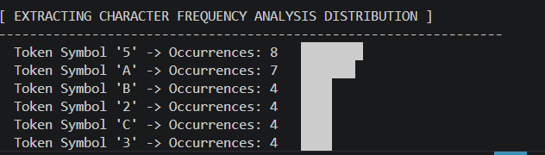
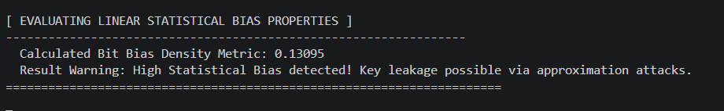

Challenge Task
Block Cipher Security Analyzer.

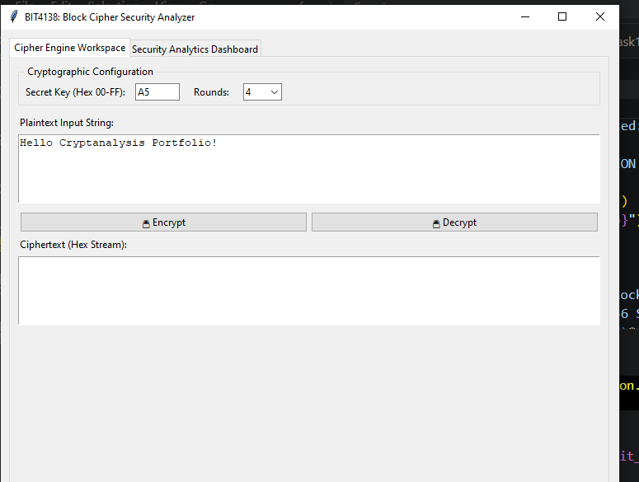
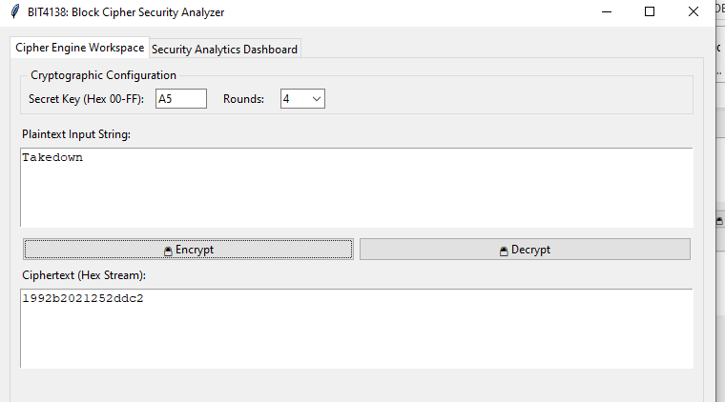
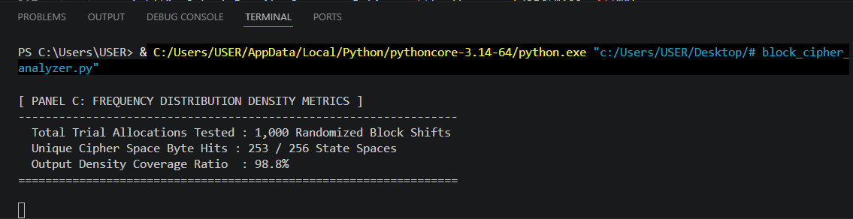

Student reflection
While printing out my hex tracking table, my script crashed with a cryptic python error: Value Error: Invalid format specifier 'X:<8' for object of type 'int'.I had to dive back into Python’s f-string documentation. I realized I had inverted the formatting rules by trying to pass the hex conversion character (X) before the column layout padding directive (<8). Flipping the syntax to {a:<8X} instantly fixed the layout alignment. It was a small syntax error, but fixing it taught me a lot about formatting clean terminal reports.

WEEK 8: Public Key Infrastructure (PKI) and Digital Certificates

Practical Task

OpenSSL Certificate Inspection

Fig 1: Download a website certificate
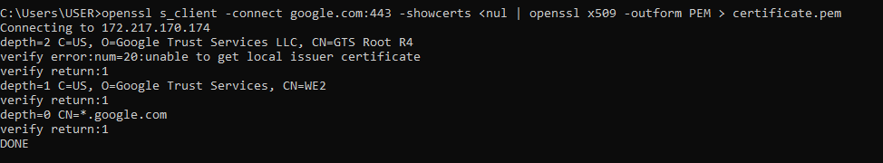

Fig2: Verifying certificate details
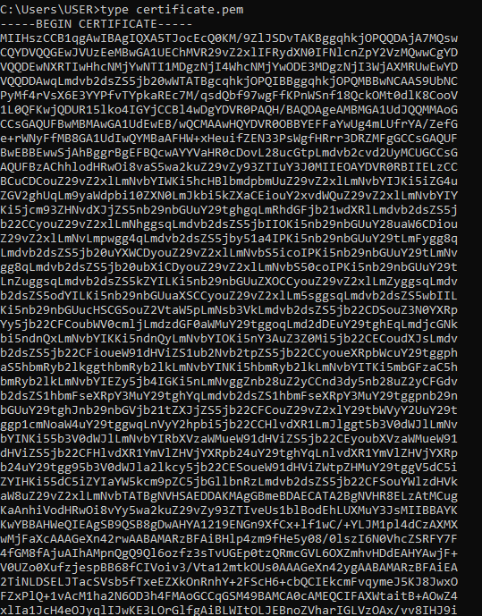
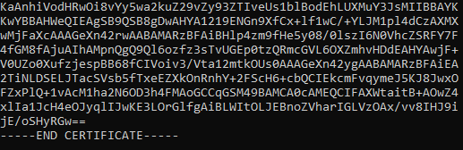

Fig 3: Identify certificate details Issuer,Subject,Signature algorithm,Expiry date
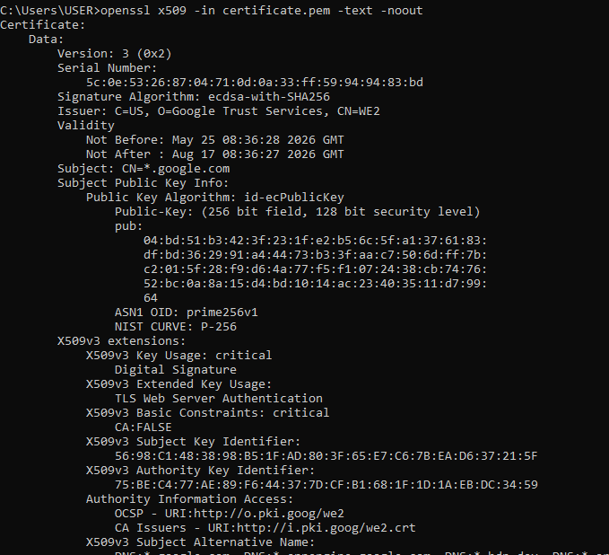
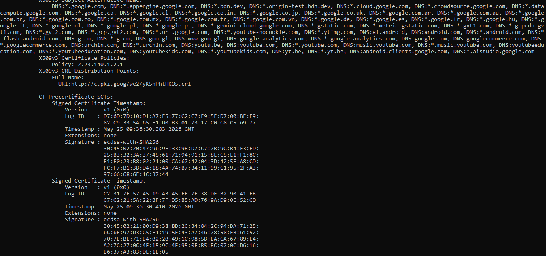
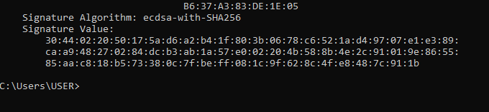

Assignment

Public Key Infrastructure (PKI) Security Incident Report
Case Study: The DigiCert Support Portal Compromise and Code Signing Abuse

1. Organization Involved
- Primary Entity: DigiCert Inc., one of the world’s largest and most trusted Certificate Authorities (CAs). They are responsible for issuing the digital certificates that keep websites secure and verify that software hasn't been tampered with.
- The Fallout: The breach didn't just affect DigiCert; it went down to software developers relying on their high-assurance Extended Validation (EV) Code Signing certificates, and ultimately threatened everyday users running software on Windows operating systems.

2. Cause of the Incident
This breach happened because an attacker succeeded through a mix of human psychology and subtle flaws in internal software design.

The Initial Trick
The attack began when a threat actor contacted DigiCert’s front-line support team via a live-chat portal, pretending to be a customer experiencing a technical issue. To "prove" their problem, they sent a zipped file masquerading as an innocent screenshot.
When a support agent opened the file, they unknowingly executed a hidden Windows Screensaver payload. This gave the attacker a foothold on an internal workstation. From there, the attacker moved laterally to a secondary computer where endpoint monitoring software happened to be misconfigured, leaving the security team blind to the intrusion for nearly two weeks.

Exploiting the Support Tools
Once inside DigiCert’s internal network, the attacker bypassed standard Multi-Factor Authentication by hijacking active login sessions. They targeted an internal support panel that featured a "proxy view"—a tool meant to let agents see exactly what a customer sees to help them troubleshoot.
While the tool correctly blocked agents from changing major security settings, it made a critical design mistake: it displayed highly sensitive Order Initialization Codes in plain text.

3. Impact on Users
- Weaponized Trust: Armed with those initialization codes, the attackers generated 27 completely authentic EV Code Signing certificates. They used these legitimate certificates to sign a dangerous strain of data-stealing malware known as Zhong Stealer.
- Bypassing the Guards: Because the malware carried a genuine, trusted digital signature from a tier-one authority, security systems like Windows SmartScreen and anti-virus programs treated it as safe, allowing it to run on victim machines without a single warning.
- Collateral Damage: To stop the attack, DigiCert had to immediately revoke a total of 60 certificates. This included 33 pending orders from completely innocent organizations whose accounts happened to be caught in the crossfire, instantly halting their software releases.
- Global Security Confusion: The ripples of the incident caused automated security tools to overcorrect. Microsoft Defender briefly flagged entirely legitimate DigiCert certificates as malicious, disrupting businesses worldwide until a corrected patch was pushed out.

4. Corrective Actions Taken
Once the abuse was discovered via external threat intelligence, DigiCert's security teams scrambled to lock down the system:
- Surgical Revocations: They wiped out all 27 fraudulent certificates and neutralized the 33 adjacent pending profiles, backdating the revocation to ensure the malware could no longer pass as trusted.
- Redesigning the Software: Engineers stripped out the clear-text visibility of sensitive cryptographic codes from the support portal's proxy view, ensuring that no internal agent—or intruder—could see them.
- Hardening the Gates: The company implemented strict perimeter rules on support channels to automatically block high-risk file extensions (like .exe and .scr) buried inside attachments.
- Fixing Blind Spots: Security audits were run across every single endpoint to fix configuration gaps in their detection software, ensuring lateral movement wouldn't go unnoticed again.

5. Lessons Learned for PKI Security
- Look Beyond the Vault: For decades, the tech industry has focused on locking down the ultimate cryptographic keys inside heavy physical vaults (Hardware Security Modules). This incident shows that attackers don't need to steal the keys if they can just trick an internal support tool into signing things for them. The peripheral systems matter just as much as the core vault.
- Mask Sensitive Data Everywhere: A "Zero Trust" model must apply to internal corporate tools. Even well-meaning employees should never have clear-text visibility into high-value authentication secrets if it isn't strictly necessary for their job function.
- Support Desks are High-Risk Ingress Points: Frontline customer support teams are inherently vulnerable because their daily job is to trust and help strangers. Because of this, files received through support channels must be rigorously sandboxed and handled with the same paranoia as untrusted web traffic.
- Community Vigilance is Crucial: The breach was caught because external researchers noticed validly signed malware in the wild, not because an internal alarm went off. CAs must deeply integrate with community threat intelligence and track public Certificate Transparency logs in real time to spot when their trust is being abused.

Practical Task

Implementing Diffie-Hellman Key Exchange
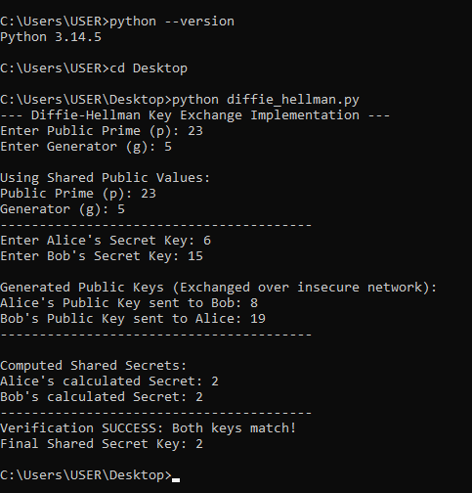

Fig1:shows diffie hellman key implemenation

Assignment
1. Definition of Diffie-Hellman
The Diffie-Hellman Key Exchange is a cryptographic protocol that allows two communicating parties to establish a shared secret key over a public communication channel. The shared key can then be used for symmetric encryption algorithms to secure communications.
2.How the protocol works.

Step 1: Public Parameters
Two public numbers are selected:
- A prime number (p)
- A generator (g)
These values are publicly known.
Example:
- p = 23
- g = 5

Step 2: Private Keys
Each participant chooses a private key.
- Alice chooses a = 6
- Bob chooses b = 15
These values remain secret.

Step 3: Generate Public Keys
Alice computes:
A = gᵃ mod p
A = 5⁶ mod 23 = 8
Bob computes:
B = gᵇ mod p
B = 5¹⁵ mod 23 = 19
They exchange A and B publicly.

Step 4: Compute Shared Secret
Alice computes:
S = Bᵃ mod p
S = 19⁶ mod 23 = 2
Bob computes:
S = Aᵇ mod p
S = 8¹⁵ mod 23 = 2
Both obtain the same secret value:
Shared Secret = 2
An attacker observing the communication sees only p, g, A, and B, but cannot efficiently determine the shared secret.
3.The Discrete Logarithm Problem.
Given:
gˣ mod p = y
It is computationally easy to calculate y when g, x, and p are known.
However, determining x when g, y, and p are known is extremely difficult.
4. Applications in TLS/SSL
• Client and server exchange cryptographic information.
• Diffie-Hellman is used to generate a shared secret.
• The shared secret derives session keys.
5.Security challenges and possible solutions.
i)The Man-in-the-Middle Attack

Problem
Basic Diffie-Hellman does not authenticate participants.An attacker can intercept communications and establish separate keys with both parties.

Solution
- Use digital certificates.
- Implement TLS authentication.
- Employ Public Key Infrastructure (PKI).

ii) Quantum Computing Threats

Problem
Future quantum computers may solve discrete logarithm problems efficiently using Shor's Algorithm.

Solution
- Develop post-quantum cryptographic algorithms.

Student reflection
This module bridged the gap between textbook theory and actual security tools. Implementing Diffie-Hellman in Python proved how math protects data, while analyzing the DigiCert incident showed that human errors can bypass the strongest keys. I now understand how ephemeral keys keep the internet safe and why zero-trust matters.

